Mehmet Vedat Kaya

Since the technology is developing, there is a huge increase in the number of websites around the world. In 1996, when Google made a big splash, there were around 200k-300k websites online. In 2005, it was increased to about 55 million websites. This is about 275 times increase. And today, it is about 1.8 billion websites which is about 33 times more than 2005.

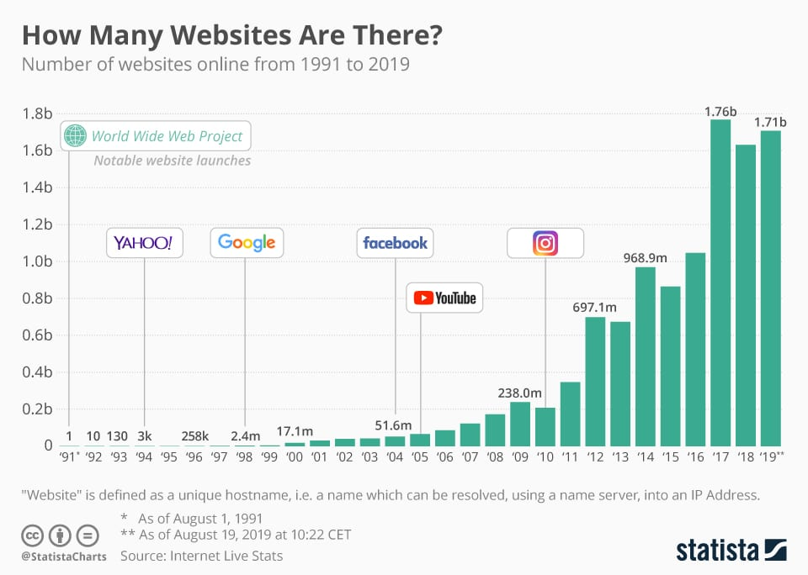

Source: https://www.digitalinformationworld.com/2019/09/how-many-websites-exist-today-on-the-internet.html